**Livrable Technique :**

ligne horizontale

# 

Source Code: lien github

Demo: video

Documentation technique complète et détaillée :

Concept explanation

Pressia is an innovative platform developed to combat fake news and misinformation in journalism. It leverages modern technologies to detect doctored images, out-of-context videos, and manipulated articles. By analyzing the authenticity of media content and sources, Pressia helps restore public trust in digital news

goals:

* Provide tools to detect and report manipulated or fake content.
* Assist journalists and citizens in verifying the authenticity of news articles, videos, and images.
* Promote transparent and responsible information dissemination.

Technical Architecture

The application follows the MVC (Model-View-Controller) pattern to ensure modularity, scalability, and maintainability.

Use case elaboration

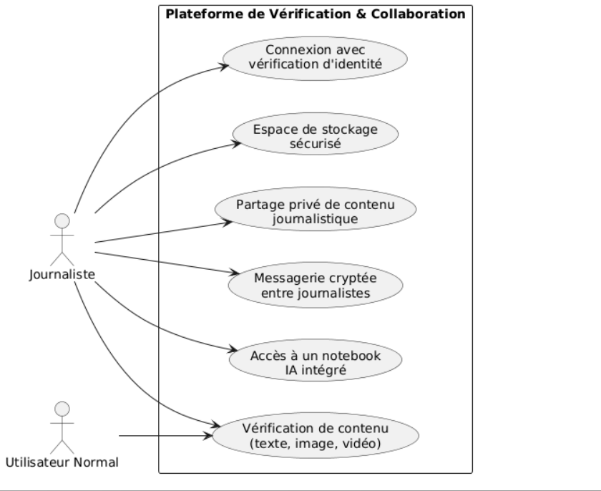

Technology Choices & Justifications

#### Django (Python Web Framework)

Justification:  
Rapid API integration and development

Security:  
 Django provides protection against common vulnerabilities such as SQL injection, cross-site scripting (XSS), cross-site request forgery (CSRF), and clickjacking. Passwords are hashed using industry-standard algorithms (e.g., BCrypt).

Scalability and Flexibility: